Course Project, Using OMNeT++ Simulator

* Installing OMNeT++ ¡OMNeT++ (http://www.omnetpp.org/) is available for various platforms. See the download page for more details. Once downloaded, uncompressed and untarred the installation file read the INSTALL and README files.

<https://omnetpp.org/download/>

<https://docs.omnetpp.org/>

https://docs.omnetpp.org/tutorials/tictoc/part1/

* Execute the file (mingwenv)

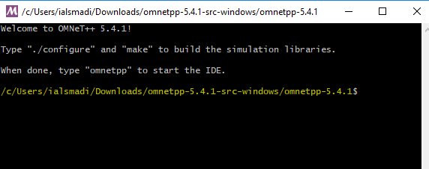

* Run the following 3 commands in MinGW

$ . setenv

$ ./configure

$ make

* After long time of installation process, type omnetpp to start the IDE

You should now test all samples and check they run correctly. As an example, the aloha example is started by entering the following commands: $ cd samples/aloha $ ./aloha By default, the samples will run using the graphical Qtenv environment. You should see GUI windows and dialogs

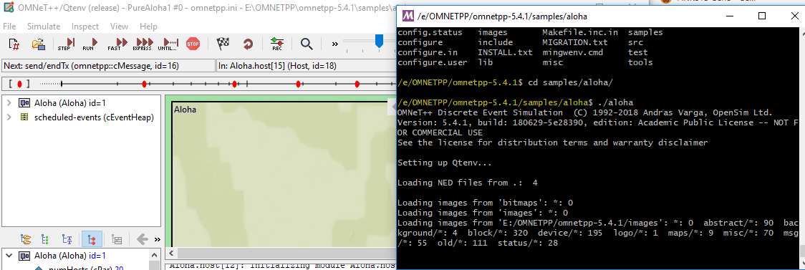

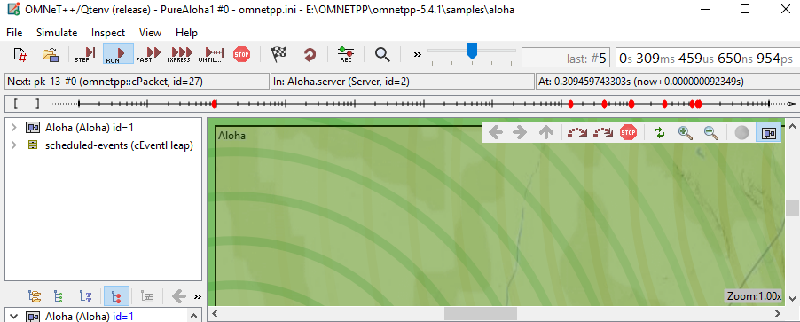

(/c/Users/ialsmadi/Downloads/omnetpp-5.4.1-src-windows/omnetpp-5.4.1$ )

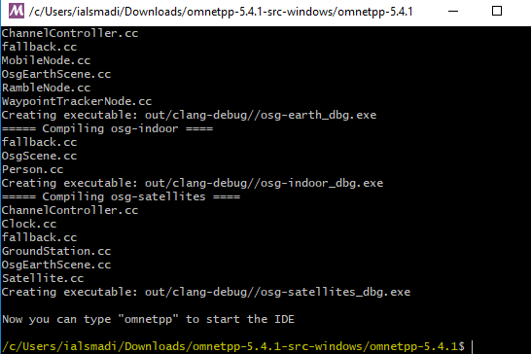

This lab will be marked complete after the successful launch of the application

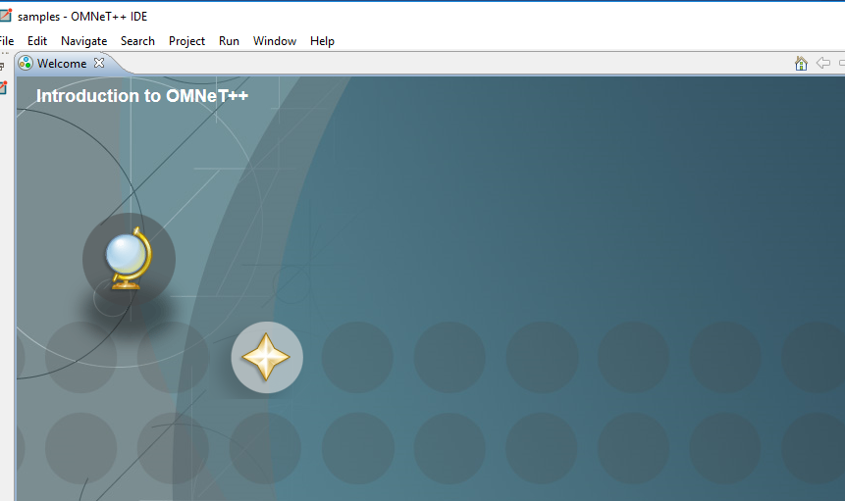

If you close it to start again click (mingwenv) and type omnetpp

---------------------------------------

* Next step is to install the INET Framework: http://inet.omnetpp.org/ INET is an open-source communication networks simulation package for the OMNeT ++ simulation environment. £ Contains models for several wired and wireless networking protocols, including UDP, TCP, SCTP, IP, IPv6, Ethernet, PPP, 802.11, MPLS, OSPF, and many others.
* After unpacking the INET tarball (tar xvfz inet-2.1.0-src.tgz), start the OMNeT++ IDE, £ import the project via File->Import->Existing Projects to the Workspace, and £ build with Ctrl+B

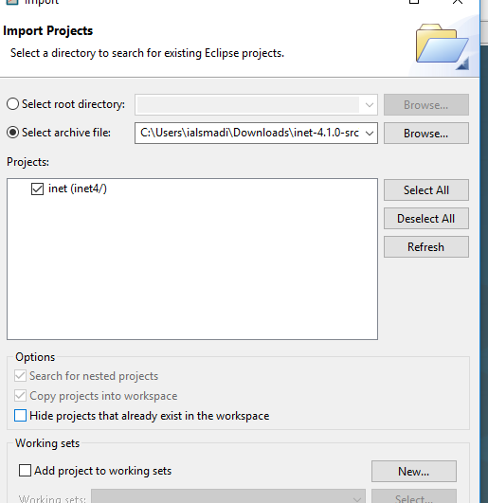

* Create a Simulations directory ¡Right click on inet, and…